SKILLS FOR FREEDOM
Newsletter from India
No: 14 June: 2016
This electronic newsletter from PEACE TRUST, INDIA is addressed to NGO's, Social Activists, Media, Opinion makers, Leaders and Bureaucrats for improving their understanding on skilling the youth for gainful employment and addressing social issues like modern slavery, child labour, migrant labour, un-employability of youth. We also send this to people who we believe are involved in improving the migrant worker's conditions. You are welcome to unsubscribe yourself, if you so choose.
-EDITOR

Peace Trust is a Non Government Organization working on Child Labour and Bonded Labour issues since 1984. It has also focused on Migrant workers rights issue since 1999.
- Peace Trust’s Skills for Freedom is the only solution to end Modern Slavery in Tamil Nadu. It is a joint effort for enhancing the employment opportunities of rural youth in Dindigul, Karur, Tiruppur Districts.
- Reduce the risk for Young Workers - Beginning of this month Peace Trust has launched a new Initiative to "Support School Education, Health Protection, Livelihood Development and Skill Training for Gainful Employment among Vulnerable Young Population in Dindigul District".
- SPSC Vocational Education & Employment Facilitation Centre provides access to vocational education and employment facilitation for rural poor youth in Nagapattinam, Thiruvarur District Tamil Nadu and Karaikal District, Puducherry.
- Peace Trust also provides training for Quality Teacher Education and gainful employment to young women from resource poor families in Dindigul and Karur District.
The views expressed are not of the donors but a compilation of field realities for the purpose of sharing and action.
The Skills for Freedom e-newsletter is published by:

Peace Trust
Near Police Housing Colony
Trichy Road, Dindigul-624005,
Tamil Nadu, India
Ph:0451-2410021; Fax:0451-2410372
Email: info@peacetrust.in , chairman@peacetrust.in
Website: www.peacetrust.in
Edited By: Dr. J. Paul Baskar Ph.D.
Assisted By: Ms. Anitha Palanivel, Mrs. Chitra

We partner with

MIGRANTS
SEPARATE CUT-OFFS FOR KASHMIRI MIGRANTS
Starting this year, Delhi University will declare separate cut-offs for the Kashmiri migrant category too, for which the varsity has a five per cent supernumerary quota over and above the available number.
According to university officials, this is also the first time they are starting to include students from outside Delhi and Jammu in the category.
“So far, the university used to announce cut-offs list for five categories including General, OBC, SC, ST and PWD. However, there will be separate cut-off for Kashmiri migrants from this year,” a senior official said.
“Also, Kashmiris from outside Delhi and Jammu will be eligible for admissions under the five per cent supernumerary quota,” he added.
A concession of maximum 10 per cent in the last cut-off list for the general category candidates is also extended to candidates under the Kashmiri migrant category. The reservation, however, is not applicable to courses where admissions will be based on entrance exams.
Minimum eligible criteria
Candidates applying under this category are required to fulfil the minimum eligible criteria prescribed by the university, submit a certificate of registration as Kashmiri migrant, proof of property in Kashmir and proof of current residence in Delhi along with their applications. All these besides other regular documents.
Admission through this quota does not take place with the general admissions process since this quota is “over and above” other reserved categories of the university.

ASSAM MIGRANT WORKER KILLED IN KERALA: ‘MORE THAN 50 MEN WATCHED. NOBODY BOTHERED TO HELP’
More than 50 men watched as Kailash Jyoti Borah (29), a migrant worker from Assam who was mistaken for a thief, tied up and left to die in the sun, struggled to free himself in his final moments, an eyewitness said.
“More than 50 men watched …Although he was foaming at the mouth, no one took him to hospital. Everyone waited till police arrived,” said Salamma, who runs a grocery shop near Chiramuttam Mahadevar Temple. Kailash was chased by a mob till he collapsed outside the temple. “He turned violent after people tied his legs. First he tried to free his legs. When he failed, he started throwing stones at the mob, which overpowered him and tied his hands behind his back,” Salamma added. Kailash was reportedly left out in the sun from 11 am to 1.15 pm.
Appu, a college student who was at the spot said, “He was in agony. But, people thought he was trying to escape. Everyone stood watching. When police came, they freed his hands and legs, but he did not move…”
Kailash, a Class XII dropout from Naamti Khongiya village in Assam’s Sivasagar district, had come to Kerala looking for work.
“His father Bimola Prasad Borah, a retired railway employee, has been quiet since yesterday, while his mother Renu has been inconsolable…Kailash went to different places including Guwahati, Dibrugarh and Jorhat looking for work. But failing to find a job for the past 10 to 12 years, he had become frustrated, until he got news that there was work in Kerala …He went to Kerala with two other boys from our village,” said Kankan Jyoti Borah, his cousin.
After boarding Vivek Express from Mariani Saturday, Kailash and his friends — Gokul Gogoi and Rupam Gogoi — reached Kottayam at 4 am Wednesday.
“From there, we boarded a bus to Chingavanam, where a few others from our area are already working in a pipe factory…But when we got down, we could not find Kailash,” said Gokul Gogoi from Chingavanam.
Locals at Malakunnam near Chingavanam said Kailash was spotted walking along the railway tracks in the area at 10.30 am. “He was screaming and tried to rush into my house. But I chased him away,” said Mini, a housewife. He reportedly tried entering other houses, but was chased away.
Chingavanam SHO, M S Shibu, however, said Kailash did not attack anyone or damage any property. “His colleagues said he was addicted to liquor. He had shown restlessness for want of liquor during the three-day train journey.”
Many villagers who encountered Kailash said they could not understand what he said. “He might have sought water from these houses, but our people could not understand his language,” said one Indira Rajendran.
On Thursday afternoon, Kankan left for Kottayam by a flight to bring the body back home.
“His cousin, a BSF jawan, is coming Friday. After that, we will decide whether the body should be cremated here or flown to Assam,” said DC Swagath Bhandari, adding that the state government had announced a compensation of Rs 50,000 for the victim’s family.

700 MIGRANTS FEARED DEAD IN MEDITERRANEAN SHIPWRECKS: UN
Over 700 migrants are feared dead in three Mediterranean Sea shipwrecks south of Italy in the last few days as they tried desperately to reach Europe in unseaworthy smuggling boats, the UN refugee agency said today.
Carlotta Sami, spokeswoman for UNHCR, told The Associated Press by phone that an estimated 100 people are missing from a smugglers’ boat that capsized Wednesday. The Italian navy took horrific pictures of that capsizing even as it rushed to rescue all those thrown into the sea from the boat.
She said about 550 other migrants and refugees are missing from a smuggling boat that capsized Thursday morning after leaving the western Libyan port of Sabratha a day earlier.
She says refugees who saw the boat sink told her agency that that boat, which was carrying about 670 people, didn’t have an engine and was being towed by another packed smuggling boat before it capsized.
About 25 people from the capsized boat managed to reach the first boat and survive, 79 others were rescued by international patrol boats and 15 bodies were recovered.
Italian police have corroborated the account of the Thursday sinking in their interviews with survivors, but came up with different numbers. It was not immediately possible to reconcile the figures.
According to survivors, the second boat was carrying about 500 migrants when it starting taking on water after about eight hours of navigation. Efforts to empty the water – with a line of migrants passing a few 5-liter bailing cans – were insufficient and the boat was completely under water after an hour and a half, police said. At that point, the commander of the first smuggler’s boat ordered the tow rope to be cut to the sinking boat.
The migrants on the top deck jumped into the sea, while those below deck, estimated at 300, sank with the ship, police said. Of those who jumped into the sea, just 90 were rescued. Survivors identified the commander of the boat with the working engine as a 28-year-old Sudanese man, who has been arrested, police said.
In a third shipwreck on Friday, Sami says 135 people were rescued, 45 bodies were recovered and an unknown number of people – many more, the migrants say – are missing.
Survivors are being taken to the Italian ports of Taranto and Pozzallo. Sami says the UN agency is trying to gather information with sensitivity considering that most of the new arrivals are either shipwreck survivors themselves or traumatised by what they saw.
NGO BEGINS SURVEY OF MIGRANTS FROM DROUGHT-HIT BUNDELKHAND
Two weeks after The Indian Express reported that people were fleeing their villages in drought-hit Bundelkhand to come to Delhi in search of work and money, three NGOs have begun surveying the number of migrants in the capital.
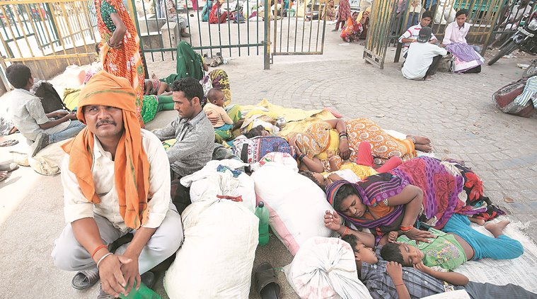
People from drought hit Bundelkhand area migrated to Delhi in search of livelihood.
Many had set up temporary shelters in a clearing under the Sarai Kale Khan flyover. Following the publication of the report, NGOs such as ActionAid, Centre For Holistic Development and Indo-Global Social Service Society visited the migrants. They said they have contacted DUSIB for setting up temporary shelters under the flyover.

INDIANS AMONG THE DETAINED MIGRANTS IN COLOMBIA, HUMAN TRAFFICKING SUSPECTED
Thirty-seven South Asian migrants, including Indians, have been detained in Colombia. The migrants were without visas and were abandoned by human traffickers, officials said.
They were found near the town Riosucio that borders Panama after being “abandoned by individuals who transported them from one country to another,” said the Colombian Navy in a release.
The migrants, 36 men and one woman, came from South-asian countries like Bangladesh, Nepal, India and Pakistan.

BONDED LABOUR
GOVERNMENT RAISED ASSISTANCE FOR BONDED LABOURERS, SAYS BANDARU DATTATREYA
The labour minister said the government is working on a comprehensive strategy to bring employment to the core of development.
Highlighting the steps taken for bonded labour, Labour Minister Bandaru Dattatreya said the government has raised financial assistance under the Rehabilitation of Bonded Labour Scheme by five times.
Addressing the International Labour Organisation (ILO) session in Geneva, the minister said the assistance is higher for the most deprived and marginalized, women and minors.
“With a renewed commitment for eradication of bonded labour, we have escalated our Rehabilitation of Bonded Labour Scheme by increasing the quantum of financial assistance by five times from Rs 20,000 to a minimum Rs 1 lakh,” a statement from labour ministry quoted the minister as saying.

CHILD LABOUR
ANTI-CHILD LABOUR PLEDGE ADMINISTERED
Seeking to ensure that the district continued to remain child labour-free, the administration has proposed to issue a notification in the district gazette and send a proposal to the government to accord the status.
After administering an anti-child labour pledge to school students in Rameswaram on Sunday, Collector S. Natarajan said the district administration would soon begin the process for securing the child labour-free status.
“The district became child labour-free four years ago and we want to ensure that the district continued to enjoy the status,” he said.
The district has to fulfil the required guidelines and criteria prescribed by the Labour department to become eligible for child labour-free status, he clarified.
Meanwhile, the district administration and the Office of Inspector of Labour would launch an action plan by holding a series of meetings, sensitise the people and conduct inspection programmes, he said. District Inspector of Labour J. Kalidas said the department launched a drive against child labour in shops, hotels, workshops and other small industrial units ahead of the anti-child labour day, but found no child labours in the district.
The officials conducted an enquiry in respect of two labourers, a boy and a girl, employed in a shop and found them above the age of 14 years, he said.
As part of observing Anti-Child Labour Day, the department launched a signature campaign on June 10 and collected more than 2,000 signatures.
The response was good and there was a greater awareness among people against employing children below the age of 14 years as workers, he said.
The department proposed to take out a rally on Monday, marking the culmination of the programme, he said adding prizes would be distributed to school students who secured prizes in the drawing and essay competitions, organised in schools on child labour themes.

TWO GIRLS INJURED TRYING TO ‘ESCAPE’ FROM PRIVATE MILL
Two young girls working in a private spinning mill in Vedasandur were injured when they scaled the 12-foot-high compound wall of the mill in the early hours on Sunday in order to escape from the clutches of mill management.
The injured R. Pavithra (17) of Chennai and S. Ranjitha (18) of Kadambankudi village in Kumbakonam had completed Plus-Two recently. On seeing the girls outside the mill, local people brought them to Dindigul Government Hospital for treatment.
Both the girls took this drastic step to escape from the mill as they could not bear the workload and the harassment.
Narrating her condition, Ranjitha said that a woman contractor, who brought her to this mill, had assured that she could continue her studies while working. “She promised that arrangement will be made to continue my studies,” she said. “But, the mill management that received my school certificates for verification refused to return them after I joined duty. I wanted to do a degree course through distance education with my wages. But I was not allowed to join any course. We were forced to work for 12 hours in a shift. They [supervisors] have been torturing girls to extract work beyond their capacity,” Ranjitha said.
Moreover, stay home facility within the mill was very poor. Food was also not good and not served properly. “Several young girls like me have been languishing in the mill without any help,” Ranjitha complained.

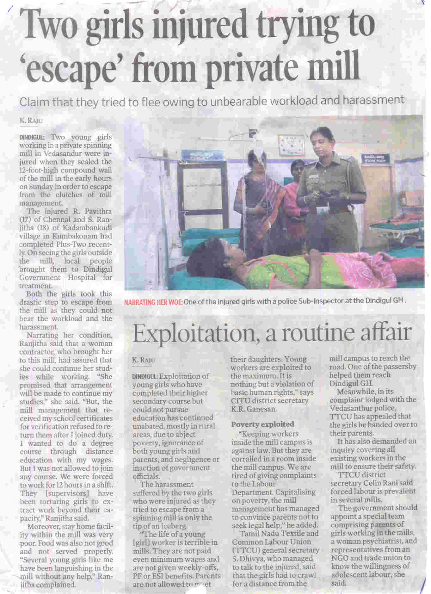

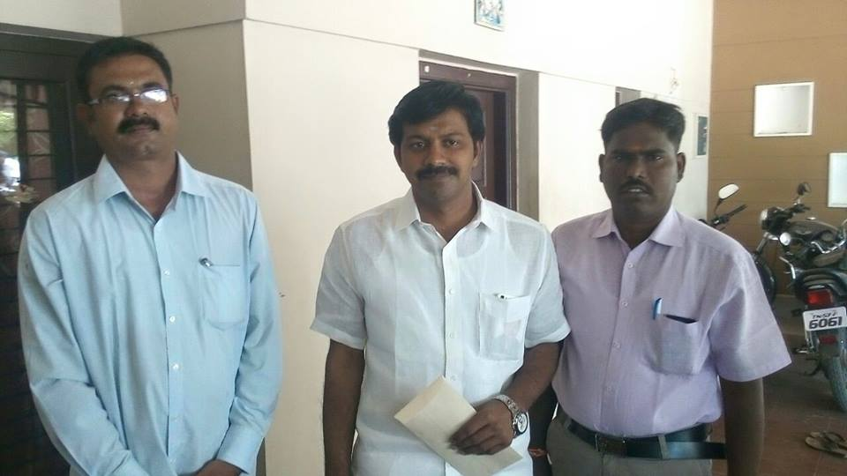
Peace Trust – Young Workers Project, Programme Manager Mr. Srinivasan (Right) and Liasoning Officer Mr. Muruganantham (Left) met Vedasandur Member of Legislative Assembly Mr.Parasivam, regarding the above issue and requested that government should help the two girls to continue their education.

FROM VICTIMS TO ROLE MODELS
Updated: June 13, 2016
Once they had spent hours together toiling under the hot sun and survived the illegal practice of child labour while working along with their parents in jobs that kept them away from schools and denied a normal childhood, but once given a chance they excelled in studies and have become a source of inspiration to others.
Twenty-year-old P. Siva, who was rescued and eventually went on to score 1,148 out of 1,200 marks in the recently declared Class 12 results, is hoping to pursue Medicine.
But, the student belonging to the Most Backward Caste (MBC) community is unsure whether his marks will get him through the competition and help him land a medical seat.
“I did my best and have scored 1,148 marks. I want to become a doctor and serve people who are poor and who are involved in manual labour since most of them cannot afford good medical treatment.
“But I’m not sure whether I will be able to get a medical seat,” says the native of Karuppanaickenpatti in Dharmapuri district, hoping for some help to secure a medical seat in a government college.
He was in the city on Sunday to receive the prize for standing first among children who were rescued under the National Child Labour Project (NCLP) and did well in the Plus-Two exams.
He was helping his parents break stones in a private firm in Bengaluru before he was rescued.
G. Bhanupriya of Salem, 18, stood second among NCLP-rescued children in the State with 1,128 out of 1,200 marks in Plus-Two. Rescued from a powerloom mill after the NCLP officials convinced her parents and mill owner, the girl went on to score 471 out of 500 in Class 10 and 1,126 in Plus Two.
“I want to study B.Sc. Agriculture and eventually become an IAS officer,” says Bhanupriya, accompanied by her parents.
A. Ramu, who scored 1,109 out of 1,200 in Class 12 and Class 10 students S. Kavin (476/500), S. Sivarama Lakshmi (470/500) and Razak Mohammad (469/500) also received prizes for excelling well in studies.

TEXTILE SECTOR STILL IN KNOTS OVER CHILD LABOUR
Textile units in Tamil Nadu have grabbed headlines several times in the past for the wrong reasons. Non-governmental organisations, including international organisations, have alleged that child workers are employed in many textile mills and that some units that employ young women do not provide adequate facilities for those who stay in hostels within the mill premises.
Though employment of children has reduced drastically in the last few years and there are only “rare instances” now, the problem seems to persist in an industry that employs about 50 lakh workers directly in the State.
“Thanks to mandatory audits and pressure on industry to comply with norms from western buyers, child labour is almost nil in the garment sector,” says A. Aloysius, founder of Social Awareness and Voluntary Education, an NGO in Tirupur.
But, there are instances of children employed in medium-sized textile mills in areas such as Udumalpet, Dharapuram, Vellakoil, etc., he says.
Further, several north Indian workers have moved to Tirupur for work, with their families, and live in specific localities.
Their families do handwork, such as stitching buttons, and there are cases where they involve the children at home for this work rather than sending them to school. Though these children do not go to factories for work, they work out of home. This is a development in the last two or three years, he says.
According to him, the State needs to have proper monitoring mechanisms to identify employment of children in such work. Officials, textile management sources, and voluntary organisations say that one reason for employment of children in some of the textile mills is labour shortage.
But, the situation is changing, contend sources in the management. Almost 30 per cent of workers in textile mills in Tamil Nadu are from other States.
With more mills employing north Indian workers, the number of women employed has reduced drastically. Further, the mills in the State are investing heavily in automation. If 40 workers were needed for a facility with Rs. 1 crore investment 10 years ago, it is just 25 to 30 workers now in a fully integrated unit, they say.
Textile industrial associations have said that action should be taken against all units that employ child workers or those who do not provide proper facilities at hostels. They have also come out with systems to encourage compliance with labour norms.
Employable age
There are also problems for mills because according to the Child Labour Act, children aged below 14 years should not be employed. But, as per ILO convention children aged less than 18 years should not be employed. About 30 per cent of workers in textile mills are in the adolescent age group (ie 15 to 18 years).
With increasing awareness, automation, and more north Indian workers coming in, this problem will not arise any more. More and more mills are going in for 100 per cent north Indian workers or the aged above 18, the sources said.
An official of the National Child Labour Project in Coimbatore says the focus in Coimbatore and Tirupur districts is on textile units and domestic sector. Special drives were conducted among north Indian workers in Tirupur in the last two years and children were rescued.
There will be more awareness programmes and enforcement drives among these workers to ensure children are not employed in any work, the official said.
Though availability of north Indian workers has improved the situation, child labour is still an issue

TEACHER BURNS 4TH GRADE STUDENTS WITH CAMPHOR FIRE AS PUNISHMENT
CHENNAI: A teacher from Viluppuram district was suspended on Thursday after she burned her primary school students with camphor fire as a punishment for irregular attendance and poor academic performance.
The incident happened on Thursday morning in Paali Panchayath primary school near Ulundurpet. Vaijayanthi Mala, a 4th standard teacher, called 13 of her students and burned their feet. The students were admitted to the Ulundurpettai government hospital on Friday morning for treatment. They had blisters on their feet.
After conducting an investigation, Vilupuram district Chief Education Officer immediately suspended the teacher and ordered a further investigation by the Education Department.

ENVIRONMENT
DINDIGUL TO HAVE RS. 13.89-CRORE SOLID WASTE MANAGEMENT PROJECT
Dindigul Corporation council has approved execution of solid waste management project at an estimated cost of Rs. 13.89 crore and commissioning of a power generation plant using bio-wastes in the city.
Two resolutions to this effect were passed unanimously by the members at the council meeting held here on Tuesday. Addressing the meeting, Mayor V. Marudha Raj said that the corporation would purchase 270 pushcarts, five light collection vehicles, 137 compactor bins, one mini tipper lorry and two compactors under this project.
Besides, a resource recovery centre, compost platform and a pre-processing shed would be constructed and required machines commissioned for processing wastes. Fifty five per cent of the total project cost would be offered as subsidy under solid waste management fund, 25 per cent under local bodies fund and 20 per cent as grant under Clean India Movement, he added.
Commissioning of the 400 KVA mini power station using vegetable wastes near Dindigul taluk office under Integrated Urban Development Plan was over. Power generated from this plant would be used to operate a 30 HP motor at corporation pumping station near Rock Fort for water distribution. A sum of Rs. 6 lakh had been sanctioned to procure electric appliances to connect pumping and power stations. He said that the corporation would construct additional classrooms, a building for laboratory and office in Nehruji Municipal Higher Secondary School at a cost of Rs. 50 lakh.
The residents could now pay various taxes online, or using their debit or credit cards, for which the corporation had a tie-up with HDFC Bank. Three parks would be created in R.M. Colony, Vivekananda Nagar and Devasahaya Nagar, he added. Dravida Munnetra Kazhagam councillors complained that contractors engaged in desilting drainage channels demanded money from the residents for removing silt. The Mayor advised officials to inspect specific spots. A proposal to demolish the Siddha hospital on Round Road and construct a house for Municipal Commissioner was kept pending owing to the objection raised by DMK councillor A. Siddique. A total of 53 resolutions, mostly related to infrastructure development, were passed in the council meeting.
THE TEACHER’S LEARNING CURVE
Sitting in a largish room of a Block Development Office in Khargone district of Madhya Pradesh at 3 pm in 41 degrees Celsius heat was not quite a pleasant experience. However, neither the high temperature nor the irritating sound of the fan really mattered as the conversations unfolded over the next two hours. There was intense debate on several suggestions for teacher development and other such initiatives to contribute to improving the quality of education in the block. The group included teachers and government academic support functionaries of the block, such as the Block Resource Coordinator and Cluster Resource Persons. My colleagues from the Azim Premji Foundation were facilitating the meeting. This was one of the preliminary meetings under the ‘Voluntary Teacher Forum’ (VTF) to be initiated at the block level.
What was remarkable was that each member was participating voluntarily. It was the result of our team members’ efforts at the ground level and their trust that the Azim Premji Foundation had something valuable to proffer.
Such events are happening across the 45-odd districts where we are currently present. All this leads to the concept of the Teacher Learning Centre (TLC), that becomes a fountainhead for increasingly more teachers voluntarily participating in conversations, discussion fora, seminars, workshops, large get-together events for both teachers and children (referred to as ‘Teacher Melas’ or ‘Bal Melas’, respectively) and many more activities.
For those curious about the kind of work the Foundation does on the ground, when I explain the VTF or TLC the first question they ask is, “Why should the teachers or other functionaries participate in such events/activities?” While everyone likes the concept, there is scepticism about how it would work without a government order in a sustained manner. The reality is that thousands of teachers, teacher educators, head teachers and education functionaries are currently associated with the voluntary forums that have been created near their homes and the number is likely to grow significantly.
It is not easy at all to carry this through or make it happen. It needs enormous mobilisation by our team. And there are several issues/principles involved in creating traction with people in a manner such that it creates the urge in them to visit the space beyond school hours.
Here, I am going to deal with only two critical underlying principles.
The first principle is: ‘An indefatigable belief in basic human goodness’. Whether you relate it to Theory Y propagated by Douglas McGregor in the early 1950s or any similar theory, it simply believes in the positive energy among human beings. It believes that all people want to do something good, constructive and positive in life. It believes that professionals want to excel and do a good job in carrying out their responsibilities. It believes that teachers want to teach well and ensure that their students learn well. It believes that education functionaries want to contribute meaningfully so that the quality of school education improves. It believes that the current unsatisfactory quality of school education is not because people don’t want to do their work but because they are unable to do it due to several constraints – including their own ability to contribute. And therefore, if enabling conditions are created or if the constraints are eliminated or significantly reduced, the professionals would intrinsically want to perform better. Illustratively, teachers are unable to realise their full potential because of the poor quality of teacher education that they have received or other disabling factors that temporarily inhibit their performance and productivity.
The second principle is: ‘Understanding the process of human development’. Corporate organizations are typically known to invest significantly large amounts in training their employees. However, even my colleagues in corporate would agree that classroom training as a methodology of human development is a much failed concept. In the first 10 years of our Foundation’s experience we derived some crucial learning:
The probability of people development is higher if they voluntarily initiate the process. In other words, people need to take charge of their own development.
Classroom training does not yield significant results — especially in changing practices at work. The development effort is a combination of theory and practice where one creates a virtuous loop of learning-practicing-sharing-learning.
Mere one-time interface with the given set of people is not very impactful — especially if the objective is to cause changes in the work practices. We need to engage with people in a sustained manner over a longer period.
One type of effort or method does not work for all individuals. Different methods need to be deployed for different people. A multi-modal approach is a must — as opposed to ‘one size fits all’.
Everything in our country is on a humongous scale and our education system is no exception. The need to contribute to teacher development is at the core of improving the quality of our education system. Currently, the institutions established by the government at the State, District, Block and Cluster level are grossly inadequate to reach out to the eight million teachers engaged in 1.5 million schools – leave aside taking care of their individual capacity development needs. There is no alternative to creating ‘voluntary spaces’ for teachers to take charge of their own development. Spaces that is convenient, comfortable and conducive to teacher development. Spaces that is closer to a cluster of homes where many teachers live. Spaces that are well-equipped with learning resources such as a library, a laboratory, digital learning resources and enabled by appropriate hardware and Internet connections. Spaces that are facilitated by resource people who have a wide social, educational and subject matter perspective, who encourage meaningful discussions related to children and their development in the most meaningful manner.
The voluntary forums must identify from among the existing competent teachers those who are motivated to contribute to the development of their peers and create a much larger resource pool of teacher educators — to address the enormous dearth of such educators across the country.
If teachers develop a deeper understanding of the connection between child development and society, of the importance of the integrated nature of the so-called subjects and of the processes through which children learn more effectively they would obviously teach better. They would evaluate their own current practices and make a conscious effort to modify them.

CIVIL SOCIETY SLAMS USE OF FCRA TO TARGET NGOS
NEW DELHI: Over 700 civil society organizations from across the country has opposed the use of Foreign Contribution Regulation Act (FCRA) to target organizations working on human rights issues and with marginalized communities. Since last year foreign funding to NGOs has dropped by half to Rs 7,600 crore in 2014-2015 and over 10,500 NGOs have had their licenses suspended.
FCRA law regulates foreign funding to organizations in India. The ministry of home affairs cancelled the FCRA registration of over 9,000 organizations last year for not filing mandatory returns regarding receipt and use of foreign funding.
Describing the use of FCRA to target organizations as a "worrisome trend" Voluntary Action Network of India's Mathew Cherian said "we are today witnessing a concerted attempt being made by the state to use the FCRA law to erode the credibility of leading and highly reputed NGOs." Commonwealth Human Rights Initiative's Venkatesh Nayak said that while the government was hounding NGOs on technical grounds, it has approved an amendment permitting political parties to receive funding from foreign companies. "This is against the objectives of the FCRA law which is to insulate political parties and the electoral process from foreign business interests."
Lawyers Collective's Anand Grover said, "Since our license has been suspended we have not been able to pay our employees. We plan to challenge the suspension".

PG DIPLOMA EXAMINATION
Peace Institute of Social Work has conducted the University examination for the one year post graduate diploma in NGO Management and Watershed Management course in Peace College of Education Campus. Totally 55 students have appeared for the examination. 22 students appeared for PG Diploma in NGO Management and 33 students appeared for PG Diploma in Watershed Management. The students of this courses has written exams for the following subjects
PG Diploma in NGO Management
- Principle of NGO Management
- NGO Accounts & Documentation
- Fund Raising
- Social marketing
- Elective: Transfer of Technology
PG Diploma in Watershed Management
- Principles of Water Management
- Water Resource Management
- Water and :Land
The exam results will be announced in the coming months and the students who passed all the subjects will get certificate from Madurai Kamaraj University. This Post Graduate Diploma course will be a prerequisite for the professional who wish to shine in the development sector.

OPPORTUNITIES FOR
SKILL IMPROVEMENT OF YOUTH IN DINDIGUL DISTRICT
Peace Trust’s
Skills for Freedom Team
Overview of Dindigul
Dindigul came into existence in 1985, when it was carved out of Madurai district for administrative and economic reasons. Administratively, the district is divided into three revenue divisions, comprising 8 taluks, 14 blocks and 358 revenue villages. These sub units are governed by 4 municipalities, 23 town panchayats and 306 village panchayats.
Demographic Profile
With a population of over 21 lakh, the district contributes 3% to the total state population. However, owing to the large geographical area, the population density of the district is contained at a medium level of 364 persons per sq.km. 37.36% of its population residing in urban areas, while the annual population growth rate is stable at 1.35%. The work participation rate (WPR) is 45.03%, which is considerably lower than the working age proportion of the population. With respect to development, the district has a healthy sex ratio of 998 females per 1000 males. Its overall human development index (HDI) and gender development index (GDI) indicators are substantially lower than the state average, reflecting lower levels of development within the rural areas of the district. However, primary research suggests that the district has witnessed some significant improvements over the past few years, which have led to a rising trend in growth and development. The current phase of transition observed in the district is projected to give way to high levels of development in the future.
Economic Profile
Although Dindigul’s GDP has been growing consistently over the last few years, its contribution to the state GDP has declined over the years, from over 3% in 1999, to about 2.8% in 2006-07. This statistic might be an indicator of the slow pace of economic growth in the district, vis-a-vis other districts in the state. Average per capita income in the district is far lower than the state average, at INR 41,226.
Agriculture: As a primarily agrarian economy, a majority of the workforce is engaged in agricultural activities. About 32% of the workforce is engaged as agricultural labor, indicating higher numbers of wage laborers as compared to landholders. Further, 86% of the workers are employed for a major part of the year, reflecting low seasonal unemployment patterns. Interaction with various district level officials reveals the lack of employment options faced by the locals in Dindigul. Lower number of landholders possibly results in larger land holdings, which generates higher agricultural productivity. All the major crops sown in the district, with an exception of onion, have higher yield rates than the state averages. Most of the agricultural land in the district is highly fertile, as evidenced by primary research. Further, these land areas are mostly large in size, which enables the farmers to employ relatively well developed agricultural techniques. This has ensured that although there are relatively larger numbers of people engaged in agricultural activities, productivity of agriculture continues to remain comparatively high.
Industry: There are over 31,000 registered industrial units in Dindigul employing nearly 3.94 lakh people. There are 95 large and medium scale units, while the rest are small and micro industries. The combined turnover of industry in 2009-10 was over INR 52,000 lakh. The district is known for its textile spinning industry. Chinnalapatti is a well known centre for handlooms in the country. Dindigul is also known for its leather tanneries and lock industries. There are 60 leather tanneries and 50 lock making units situated in Dindigul. The district is also rapidly becoming a centre for food processing. The aggregate investment until 2010-11 by all industrial units is more than INR 76,800 lakh. Major investments in the near future involve mainly food processing units and cement. Rail and road transport infrastructure investments by the government will exceed INR 5,200 crore. Finally, investments worth INR 100 crore are also being made in transport and logistics services for the food processing industry in the medium term. However, over the recent years, the district has witnessed a rise in medium and small scale industrial activity with a number of small and micro industries operating within the sub sectors of coir production, agro processing
and milk products. There are a considerable number of metallurgical industries operating in the district too. Of these industrial units, about 10% are unorganized – most of them choose to register with the DIC to leverage the various benefits and subsidies provided.
Services: The service sector has seen moderate growth and is expected to contribute to 63% of the district’s output in 2012-13 as against the 50% contributed in 2008-09. At a CAGR of 17%, communication and banking are the fastest growing sectors in the district and is expected to contribute to 4% and 15% of district GDP respectively as on 2014-15. Dindigul’s service sector employs approximately 1.87 lakh people. Dindigul houses two prominent tourist destinations: the famous temple of Lord Kartikeya located in Palani, which attracts more than 70 lakh religious pilgrims every year, and Kodaikanal, a famous tourist hill station that attracts a considerable number of foreign tourists. However, the hospitality sector continues to be largely unorganized. There appears to be a general decline in the level of tourism post 2005, with a decline in the absolute number of foreign tourist arrivals. Spurred by the growing industrial development, the financial infrastructure of the district is well developed, with 123 government bank branches, 35 private bank branches and 31 co-operative banks. There are a considerable number of hospitals and health care centres too; however, the population to doctor ratio is quite low, with one doctor available for every 7,040 persons in the district. Transport infrastructure too is well developed within the district, with over 361 kms of roads connecting various parts of the district. The intra district connectivity is further enhanced by approximately 67 kms of railway route length and 18 railway stations across the district. Inter district connectivity however, seems to be low, with no major national or state highways passing through the district.

State of Education
Literacy levels are low in the district, with an overall literacy rate of 77%. However, literacy levels have improved over the past decade, especially for the females in the district. Female literacy has risen by 10%, from 58.92% in 2001, to 68.82% in 2011. Male literacy too, has improved from 79.8% to 84.91%. Although these figures depict an improvement, gender literacy gap is higher for Dindigul than other comparable districts, reflecting poor levels of gender development. Analysis of schooling education data suggests a far lower completion rate in primary schools as opposed to upper primary schools. The dropout rate, on the other hand, is higher for upper primary schools as opposed to primary schools. This suggests that the value of higher education is lower than the earning opportunities available. A number of cultural and economic constraints lead to early drop outs from schools, thereby revealing a failure to capitalize the available schooling infrastructure. There are a total of 1789 schools; a majority of them are primary schools. A significant deviation from the state trend is observed with Net Enrolment Ratios; NER for primary schools is lower than NER for upper primary schools, suggesting that a significant number of children remain uneducated in the district, which could be explained by the high poverty levels. Another possible explanatory factor can stem from social and cultural patterns – high gender disparity levels in the district suggest unwillingness on the part of the district’s inhabitants to educate girl children.
Higher education is moderately represented in the district. There are two universities, 16 arts and science colleges and 17 engineering colleges in the district. There are a number of vocational educational institutions too; most of them are ITIs set up by the existing industrial units, focusing on garnering enough skilled manpower for their factory operations. The combined capacity of all the ITIs and ITCs in the district is 3,591. These ITIs are mostly concentrated around the industrial estates, which might not facilitate skill development in all the areas of the district.
Human Resource Availability
The current work force is estimated to be 8.99 lakh, which is estimated to grow to 10.73 lakh by 2022. The incremental availability of human resources in 2017-22 is estimated to be 91,000. The highest incremental human resource availability is expected at the unskilled level, while the lowest incremental availability is estimated at the semi-skilled level.
Incremental Human Resource Requirement
The incremental human resource requirement will be highest in the unorganized sector. Tourism, hospitality and travel and construction will also show strong growth, mirroring state trends. Food processing is expected to grow on account of the plan to set up a food park in the district. Textiles are expected to show more rationalized growth. Support services such as transportation and logistics, retail and BFSI are expected to see a moderate increase in human resource requirements. The human resource requirement in the agriculture sector is expected to decline by 36,000 in 2017-22. The long term growth sectors for Dindigul are food processing and construction. The development of an enabling environment for the food processing sectors will take several years, which is why the growth of human resource requirements in food processing is relatively low, but is high for construction. Traditional industries like textiles and leather will continue strong growth on the back of an increasing export base. Competitive pressures in these sectors from other developing districts will also contribute to enhanced growth.
Skill Gap
The largest skill gap is at the semi skilled level at 74,000 in 2016-22. There is estimated to be a small gap in unskilled human resource in 2012-17, which is expected to grow in 2017-22. This indicates an overall increase in the need for lower level skills since the unskilled category includes all those with less than 10th plus 3 years of education. The skill gap at the skilled level is expected to grow significantly from 17,000 in 2012-17 to 56,000 in 2017-22. The pattern of skill gap suggests a widening gap for workers across skill levels. In 2012-17, traditional industries are expected to employ a large number of unskilled workers and remain competitive by cost cutting. However, in order to maintain competitive advantage in the long term, operating at low costs alone will not be sufficient; industries would have to invest in skill development. Service sector growth will necessitate increasing demand for skilled workers in the same period. Manufacturing industries employing semi-skilled human resources, and increasing productivity and competitiveness in traditional industries will lead to increasing demand for semiskilled and skilled human resources in 2017-2022.
Qualitative Skill Gaps
Inadequate formalization of skills: In terms of skill development, most of the workers have basic education, but very few workers enroll in vocational training programs. Formal education does not prepare the workers for work and the transition to formal employment is difficult for them. There are a few vocational training institutes and ITIs in the district. People are unwilling to pay for diploma education, especially when they could pursue a bachelor’s degree for the same amount
Career promotion at low skill levels not institutionalized: The lack of skilled labour supply leads to the industrial units becoming more mechanized. Higher levels of mechanization also lead to lower costs and greater productivity, thereby cushioning them from the possible fallout caused by the unavailability of labourers with specific skills. This trend is holds the risk of driving levels of unemployment in the future, which will limit the district’s potential for inclusive growth and development.
Low emphasis on grooming skills for local demand: Dindigul has always been an agrarian economy. Although the last few years have seen a decline in the interest to pursue agriculture, rising unemployment figures have left the district’s residents with no choice but to pursue agricultural activities. The soil is fertile and the quality of agricultural land is well-suited to increased agricultural production. Agricultural productivity is high and contributes to a significant chunk of the district economy. Despite this there are no skilling initiatives in the district to groom the population to cater to local demand.
Youth Aspirations
Skill sets and abilities do not match educational attainment: Dindigul is going through an interesting phase right now; the district is on the verge of becoming an industrialized district, much like its neighbours – Tiruppur and Coimbatore. Currently, however, the district is still primarily agrarian. But the level of industrialization is rising. The district economy is heavily dependent on agriculture, and so a large part of the district’s populace is still engaged in primary sector activities. Growing industrialization, however, means that the younger generation is averse to pursuing any form of agricultural activity. They attach a low status to jobs related to agriculture. They often seek employment in various industries. Recently, some of them have begun to set up their own enterprises. Education levels in the district have seen significant improvement over the past five years. People usually choose to get educated at least until the 10th or 12th grade in the district. Although this increased preference for education is a significant development that will facilitate the long term growth of the district, in the short term, it causes unemployment amongst skilled youth. Jobs are being generated by the industries, but the requirements for these jobs often do not match the educational qualifications of the candidates. The mismatch is not purely quantitative; it is more qualitative in nature. Often, the locals are unaware of the qualifications required to gain employment in the industry. Even if they do finish college and gain a bachelor’s degree, it does not make them employable if their skill sets do not meet industry demands. This mismatch has led to an increase in unemployment figures for the district over the last few years.
Very few youth enroll in vocational training. Gaps in basic formal education prevent skills from being absorbed in a classroom setting. Low interest in skill development may be attributed to the absence of a clear link between skill training institutes and employment and low awareness about existing skill development initiatives. The youth display a strong interest in sectors such as IT-ITES, engineering goods and automobile.
Aspirations driven by the need for financial security and retain familial ties: The major factors that affect aspirations are financial security and family. Educational background and area of residence also influence availability of information on existing job opportunities, which, in turn, contributes towards the formation of aspirations.
Reference: TamilNadu Skill Gap Assessment, National Skill Development Corporation

